Experiment 1.3

# Student Name: NITYENDRA KUMAR UID: 20BCS2720

**Branch: BE-CSE Section/Group: 20BCS-DM-901(A)**

# Semester: 6th

**Subject Name: Mobile Application Developemnt Lab**

# Aim:

Create Application by Using Widgets.

# Objective:

Create Application by Using Widgets.

Widgets are the micro-version of the application that consists of some functionality of the application that is displayed only on the Home Screens or the Lock Screen. For example, we

see Weather, Time, Google Search Bars on the Home Screen, and FaceLock, FingerprintLock on the Lock Screen, which are some of the Widgets available on the device. Widgets come along with the Application when you install it or download it from the Web. Generally, phones come with a manufacturing configuration but such elements can be adjusted by a user later in time.

# System Requirements:

Microsoft Windows 7/8/10 (32-bit or 64-bit)

4 GB RAM minimum, 8 GB RAM recommended (plus 1 GB for the Android Emulator)

2 GB of available disk space minimum, 4 GB recommended (500 MB for IDE plus 1.5 GB for Android SDK and emulator system image)

1280 x 800 minimum screen resolution Java JDK5 or later version

Java Runtime Environment (JRE) 6 Android Studio

# Steps/Program:

Step 1: Create a New Project

To create a new project in Android Studio please refer to How to Create/Start a New Project in Android Studio. We are implementing it for both Java and Kotlin languages.

Step 2: Add the App Widget to the Project

Right-Click on the app, move the cursor to new, find the “Widget” option at the end, select it.

Specify the required properties for the widget such as min. width and height, config file and preferred language, etc, and proceed. Files are automatically generated.

Step 3: Install and Run the Code

Install and Run the code on Android Virtual Device (AVD) or a personal device.

Open the widget section of the phone, lookup for a widget with the Application name, select it, bring it to the home screen.

Try changing the dimensions and we are done!

During this selecting and deploying process, a few extra files are generated and minor changes are made to existing files as well. No programming is required for generating a basic widget and is only required if an

application is to be embedded inside the widget, as discussed in the later parts of the article. Let us now explain the newly generated files the changes make to the existing ones, one by one.

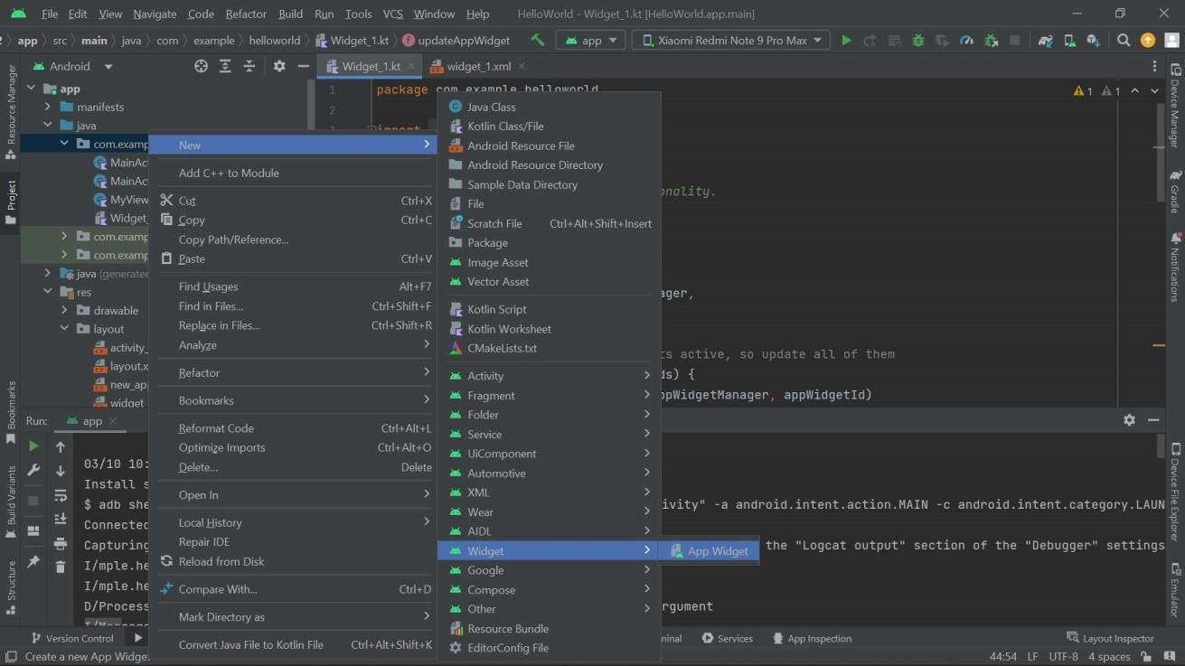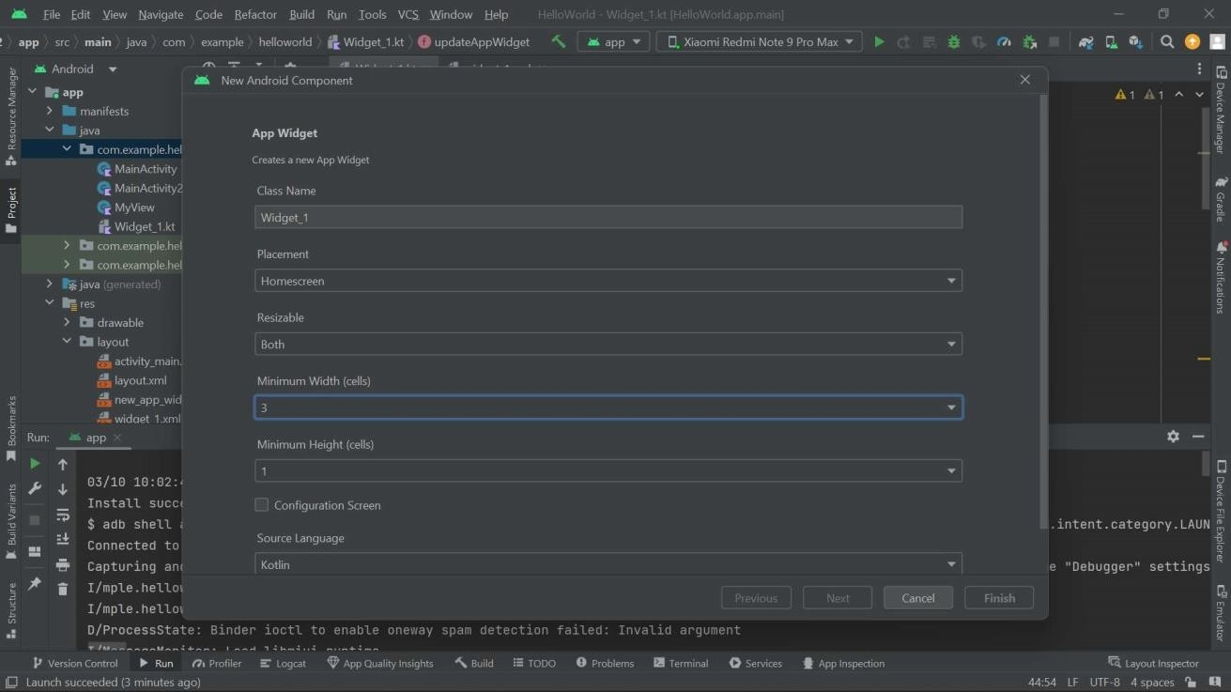

NewAppWidget.kt

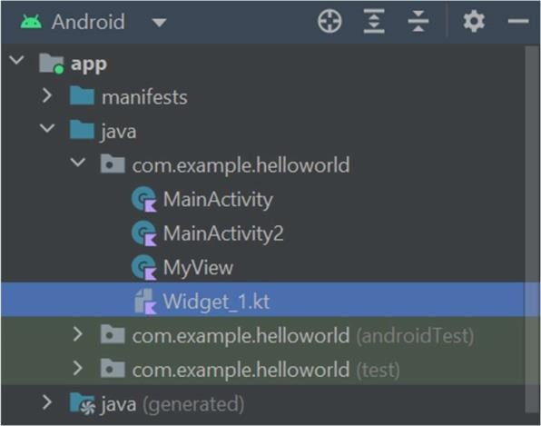

package com.example.helloworld import android.app.PendingIntent import android.appwidget.AppWidgetManager import android.appwidget.AppWidgetProvider import android.content.Context import android.content.Intent import android.net.Uri import android.widget.RemoteViews class Widget_1 : AppWidgetProvider() { override fun onUpdate( context: Context, appWidgetManager: AppWidgetManager, appWidgetIds: IntArray

) {

for (appWidgetId in appWidgetIds) { updateAppWidget(context, appWidgetManager, appWidgetId)

}

}

override fun onEnabled(context: Context) {

}

override fun onDisabled(context: Context) {

}

} internal fun updateAppWidget( context:

Context, appWidgetManager:

AppWidgetManager, appWidgetId: Int

) {

val remoteViews = RemoteViews(context.packageName, R.layout.widget_1) val intent = Intent(Intent.ACTION_VIEW) intent.addFlags(Intent.FLAG_ACTIVITY_NEW_TASK)

intent.data = Uri.parse("https://uims.cuchd.in/") val pendingIntent = PendingIntent.getActivity(context, 0, intent, 0) remoteViews.setOnClickPendingIntent(R.id.ClickMeButton, pendingIntent) appWidgetManager.updateAppWidget(appWidgetId, remoteViews)

}

2. new_app_widget.xml

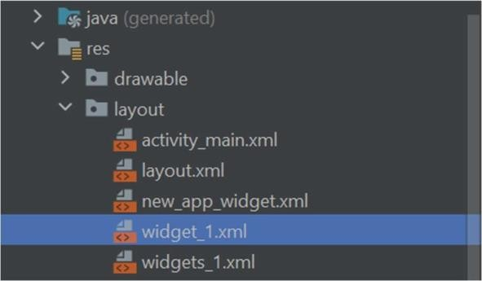

<RelativeLayout xmlns:android="[http://schemas.android.com/apk/res/android"](http://schemas.android.com/apk/res/android) style="@style/Widget.HelloWorld.AppWidget.Container"

android:layout_width="match_parent" android:layout_height="match_parent" android:theme="@style/Theme.HelloWorld.AppWidgetContainer">

<Button android:id="@+id/ClickMeButton" android:layout_width="wrap_content" android:layout_height="wrap_content" android:background="@color/purple_700"

android:text="Click Me" android:textColor="@color/white" />

</RelativeLayout>

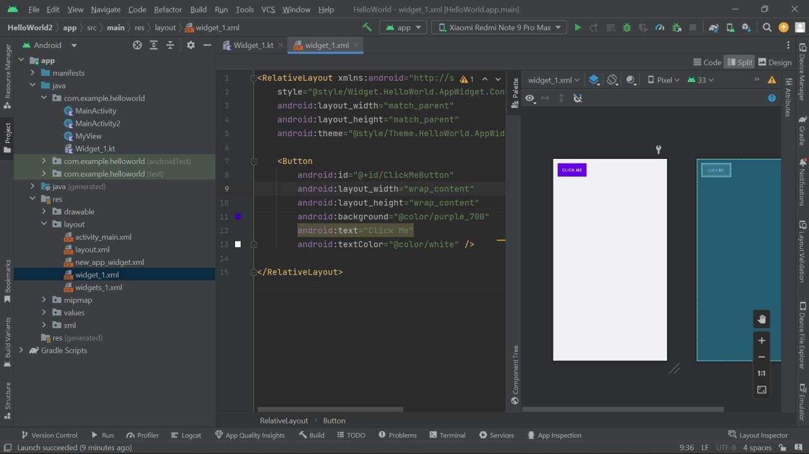

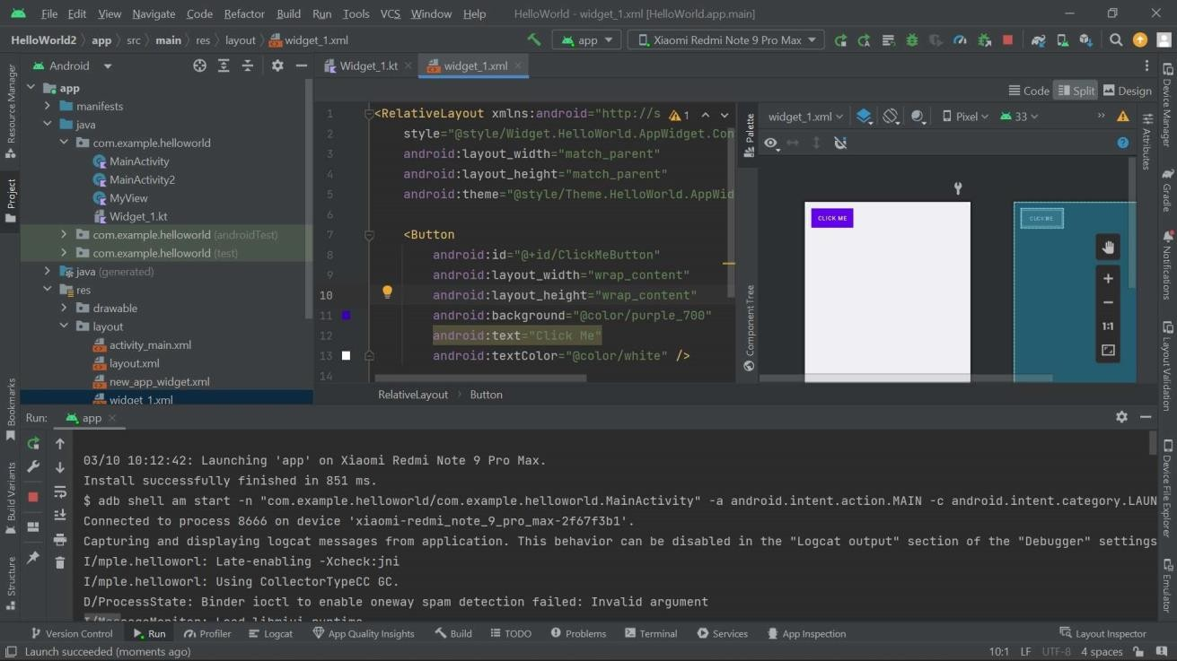

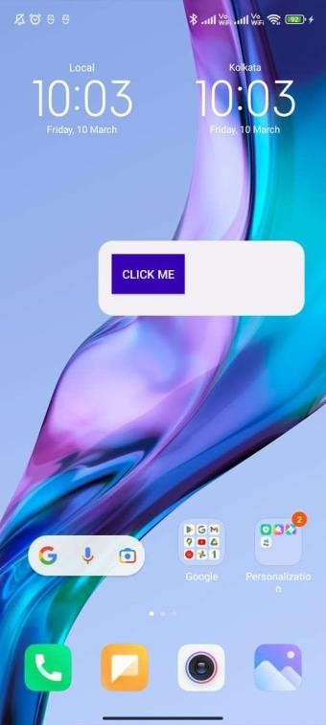

# Learning outcomes (What I have learnt):

* To design an android application which uses widget in android studio.
* Learnt about running application on android studio.